

Foundations of Programming
NAME-SARANSH PARIHAR
PRN-1262253066
DIV-11(CSE-AIDS)
Assignment No. : 10

PROBLEM STATEMENT:
Write a program in C to simulate a simple calculator that performs basic arithmetic operations such as addition, subtraction, multiplication, and division. The calculator should also perform special operations like computing xʸ (power) and x! (factorial).

OBJECTIVE:
• To understand the use of switch-case statements in C.
• To perform basic arithmetic and special mathematical operations.
• To enhance problem-solving skills using menu-driven programs.

THEORY:
A calculator is a basic computing device used to perform arithmetic operations. In C programming, a simple calculator can be implemented using conditional or switch-case statements. Arithmetic operations like addition, subtraction, multiplication, and division are fundamental operations. Special operations such as power (xʸ) and factorial (x!) require loops for repeated calculations.

PLATFORM:
Linux

ALGORITHM:

C PROGRAM:

INPUT:
User selects an operation from the menu and enters required values.
Example Input:
Choice: 1
Numbers: 10 20
Screen Shot of Input

OUTPUT:
Example Output:
Result = 30.00
Screen Shot of Output

CONCLUSION:
Thus, a simple calculator program was successfully implemented using C programming. The program demonstrates the use of switch-case statements, loops, and arithmetic operations.

FAQs:
- What is a simple calculator program?
- Why is switch–case preferred in calculator programs?
- How does the program handle division by zero?
- How is the power operation (xʸ) implemented without using math library functions?
- What is factorial and how is it calculated using loops in C?

CODE:
#include <stdio.h>

int factorial(int n) {
int fact = 1;
for(int i = 1; i <= n; i++) {
fact = fact * i;
}
return fact;
}

int power(int base, int exp) {
int result = 1;
for(int i = 1; i <= exp; i++) {
result = result * base;
}
return result;
}

int main() {
int choice;
int a, b;
printf("Simple Calculator\n");
printf("1. Addition\n");
printf("2. Subtraction\n");
printf("3. Multiplication\n");
printf("4. Division\n");
printf("5. Power (x^y)\n");
printf("6. Factorial (x!)\n");
printf("Enter your choice: ");
scanf("%d", &choice);
switch(choice) {
case 1:
printf("Enter two numbers: ");
scanf("%d %d", &a, &b);
printf("Result = %d", a + b);
break;
case 2:
printf("Enter two numbers: ");
scanf("%d %d", &a, &b);
printf("Result = %d", a - b);
break;
case 3:
printf("Enter two numbers: ");
scanf("%d %d", &a, &b);
printf("Result = %d", a * b);
break;
case 4:
printf("Enter two numbers: ");
scanf("%d %d", &a, &b);
if(b != 0)
printf("Result = %.2f", (float)a / b);
else
printf("Division by zero is not allowed");
break;
case 5:
printf("Enter base and exponent: ");
scanf("%d %d", &a, &b);
printf("Result = %d", power(a, b));
break;
case 6:
printf("Enter a number: ");
scanf("%d", &a);
if(a >= 0)
printf("Factorial = %d", factorial(a));
else
printf("Factorial not defined for negative numbers");
break;
default:
printf("Invalid choice");
}
return 0;
}

OUTPUT SCREENSHOT:
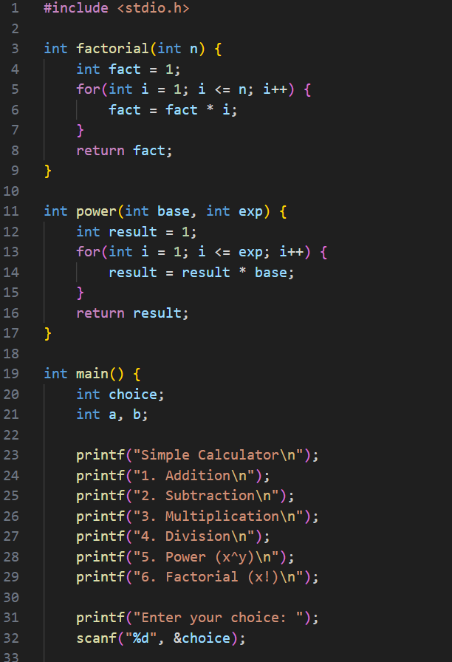

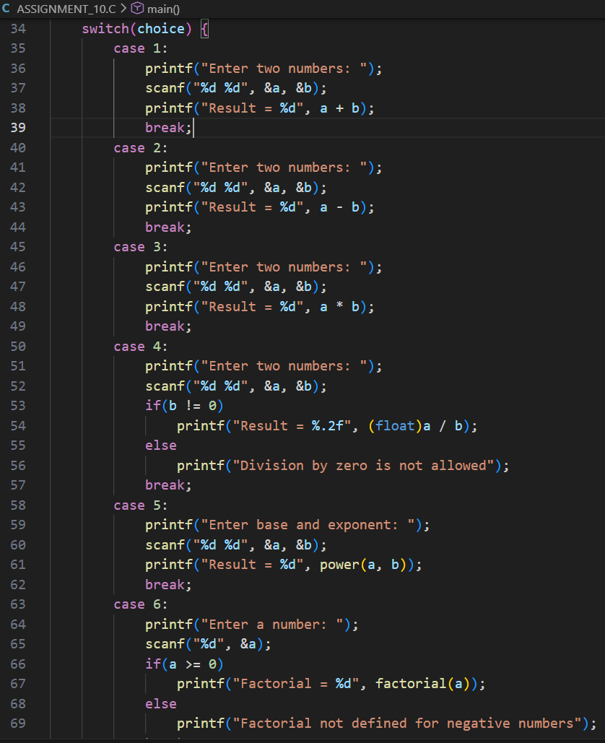

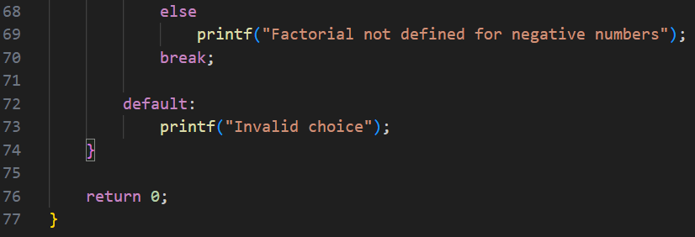

OUTPUT SCREENSHOT:
